**WiRobot**

**Group Members**

**Ashutosh kakadiya 1401075**

**Deep Talati 1401085**

**Harsh Mehta 1401086**

**Kishan Raval 1401117**

**List of components**

1. Wifi Modual ESP8266

2. Motor Driver L293D

3. AtMega16

4. Motors

5. LDR Sensor

6. Cart (Including 2 motors and 4 tyres)

7. LEDs

**Hardware Photos**

* **LDR ESP8266**

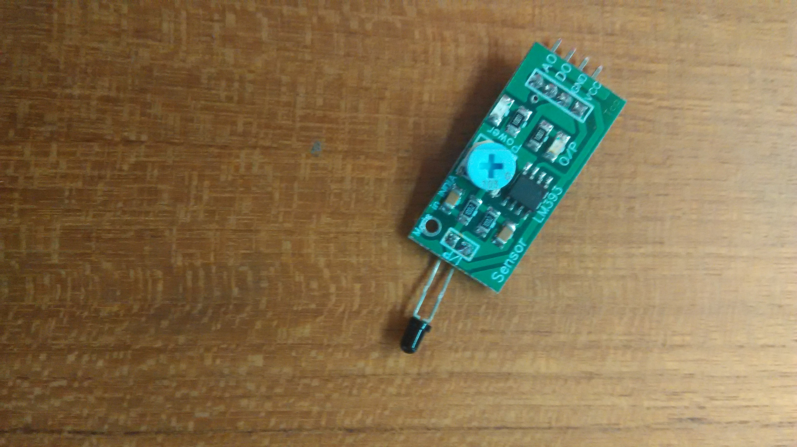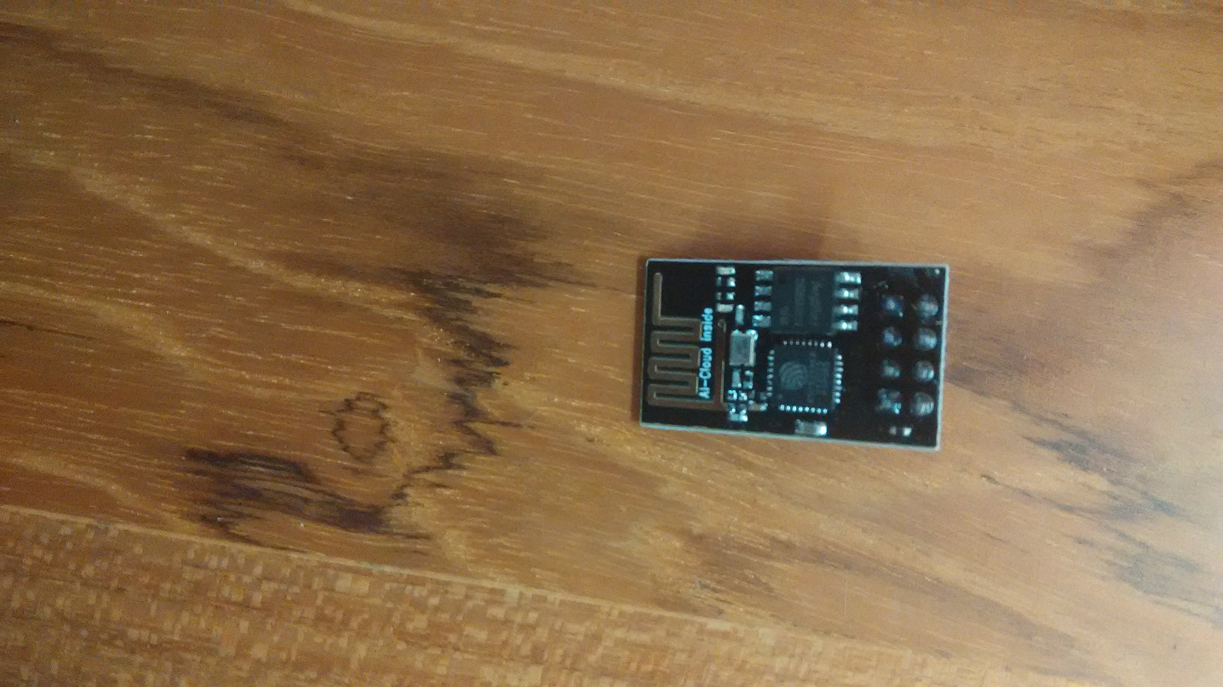

* **Car**

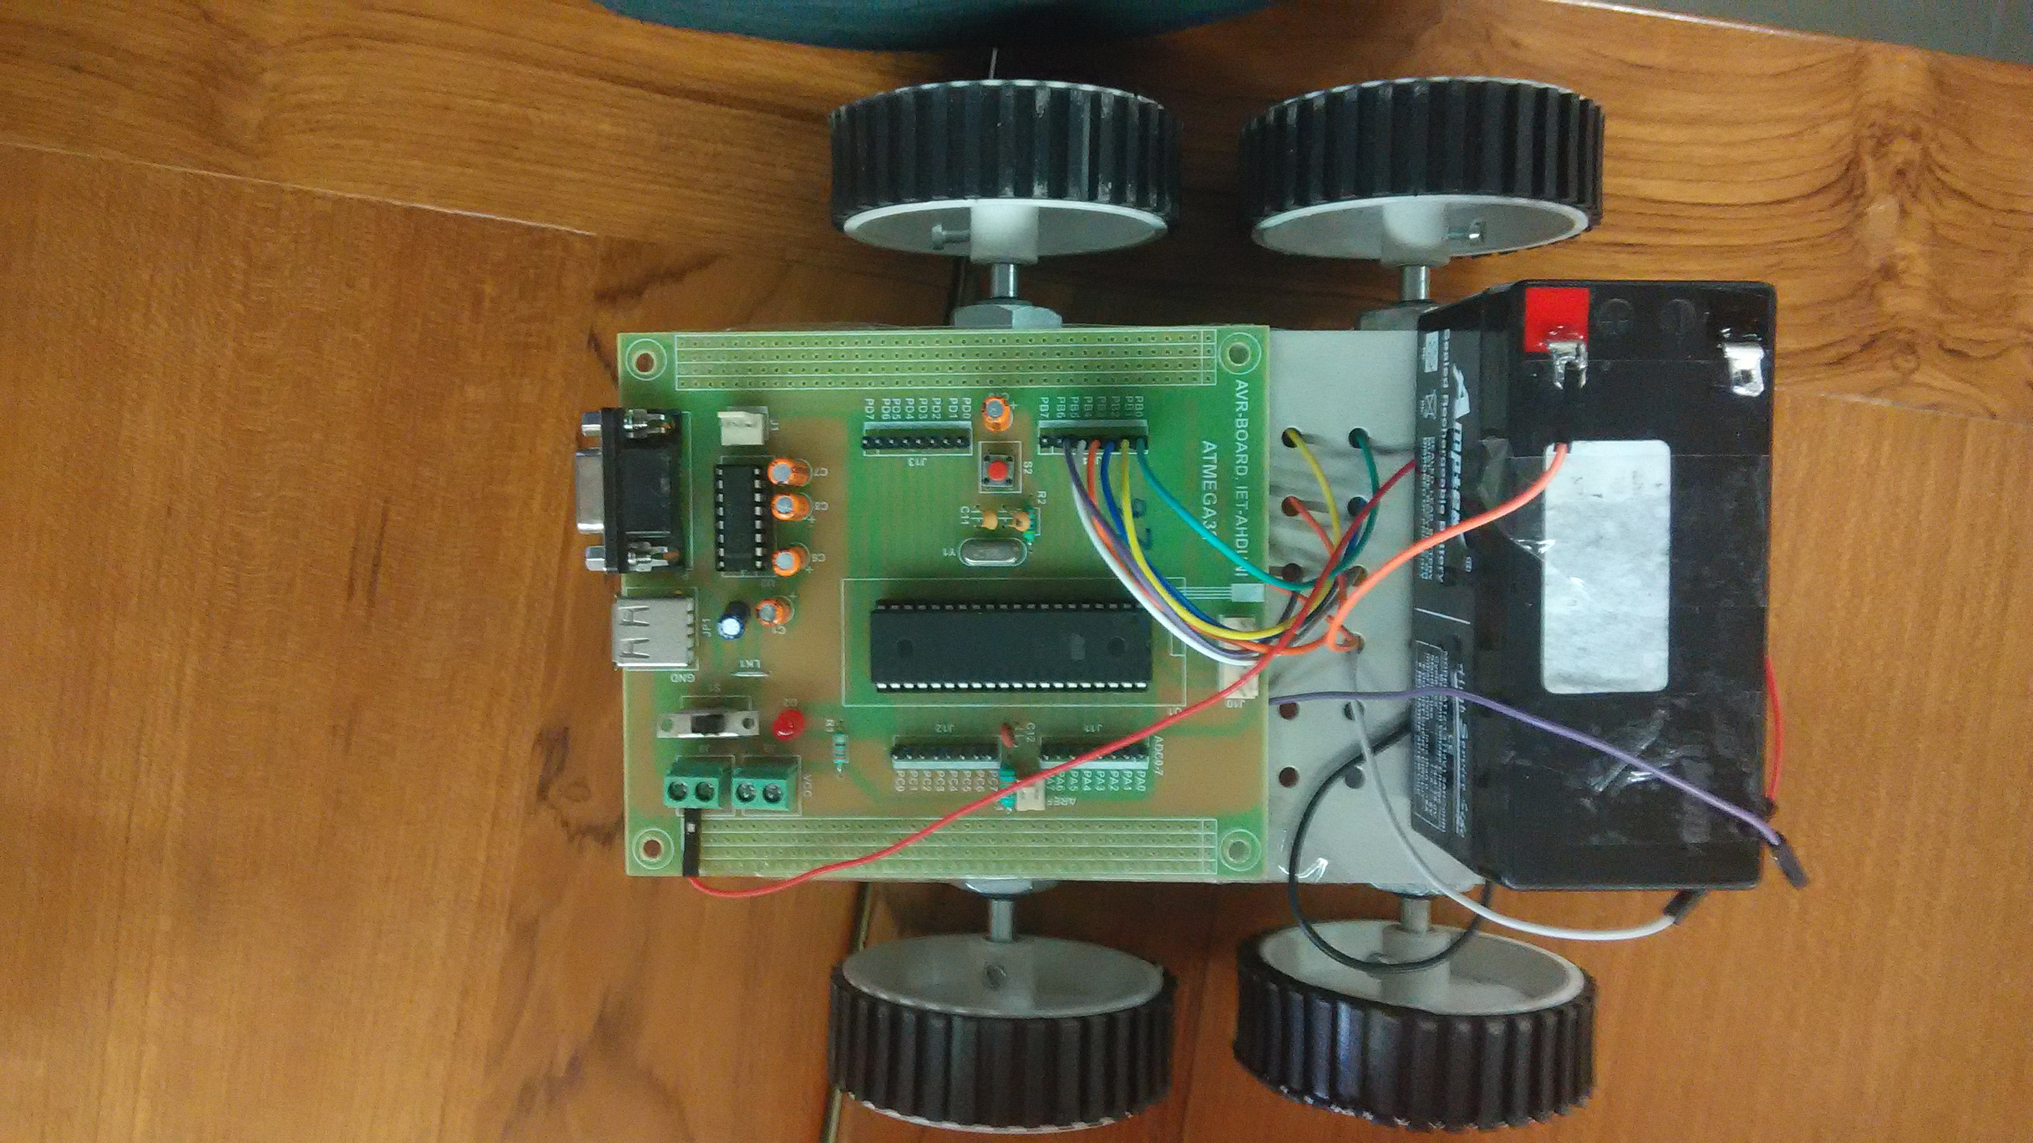

**Code**

void main() {

int LDRvalue;

DDRB = 0x3F;

PORTB = 0X30; // To Enable the motor driver

while(1) {

LDRvalue = PIND.B0; // Storing the output of LDR sensor

if(LDRvalue == 0){

PORTD.B1 = 0;

}

else {

PORTD.B1 = 1;

}

//Forward direction

PORTB |= 0x0A;

Delay_ms(5000);

PORTB &= 0xF0;

Delay_ms(2000);

//BackWard diraction

PORTB |= 0x05;

Delay_ms(5000);

PORTB &= 0xF0;

Delay_ms(2000);

//For left turn

PORTB |= 0x02;

Delay_ms(2000);

PORTB &= 0xF0;

Delay_ms(2000);

//For right turn

PORTB |= 0x08;

Delay_ms(2000);

PORTB &= 0xF0;

Delay_ms(2000);

}

}